
Arab Academy for Science, Technology, and Maritime Transport
College of Engineering – Computer Engineering Dept.
Course | ECE3403 – Data Analytics & Optimization
Lecturer | Dr. Karma Fathalla – Dr. Doaa Shoieb
TAs | Yasmina Ayman – Hoda Osama – Marwan Nour

Sheet 4 - Data Pre-processing and Cleaning

Question 1:
For the Titanic dataset, perform primary data analysis by following these steps:
- Load the dataset in Jupyter Notebook.
- Examine the structure of the dataset, including the variables, data types, and their meanings.
- Conduct exploratory data analysis (EDA) using descriptive statistics and visualizations to uncover patterns, trends, and relationships.
- Identify and handle missing values.
- Detect and address outliers using appropriate statistical methods or visualizations.
- Apply normalization or standardization to variables that require scaling for further analysis or modeling.

Question 2:
Apply the following normalization techniques to the Iris dataset in two ways:
- Manually on the provided sample from the dataset.
- Using Python for the entire dataset.
Normalization Techniques to apply (considering the statistics table of these attributes):
- Min-Max Normalization
- Z-score Normalization
- Decimal Scaling Normalization
Compare the results from the manual calculations and the Python output.
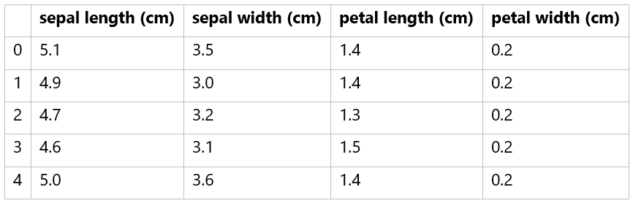
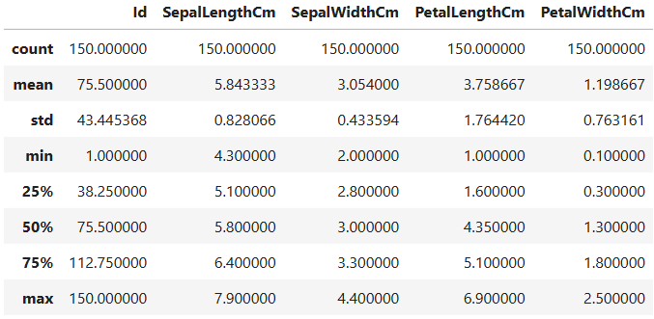

Question 3:
For each of the following examples:
- Identify the type of missing data (MCAR, MAR, or MNAR).
- Propose an appropriate approach to handle the missing data manually.
- Implement the same approach using Python.
Example 1: Survey Dataset (Missing Income Data)
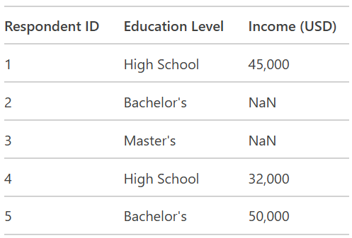

Example 2: Medical Dataset (Missing Blood Pressure Data)
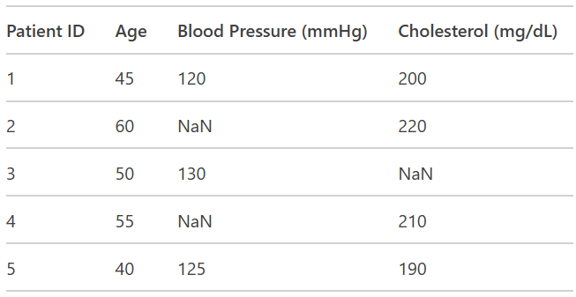

Example 3: Customer Dataset (Missing Satisfaction Data)
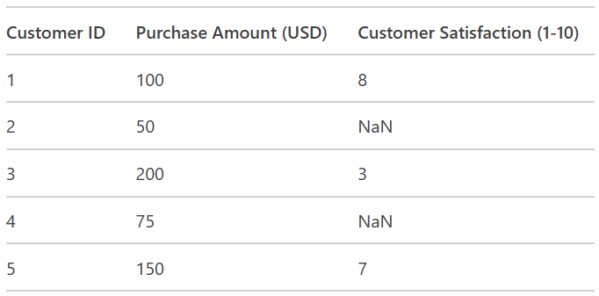
Question 4:
The volume of 𝑪𝑶𝟐 a machine produces was measured 900 times in June. These volumes are displayed in the cumulative frequency graph below.
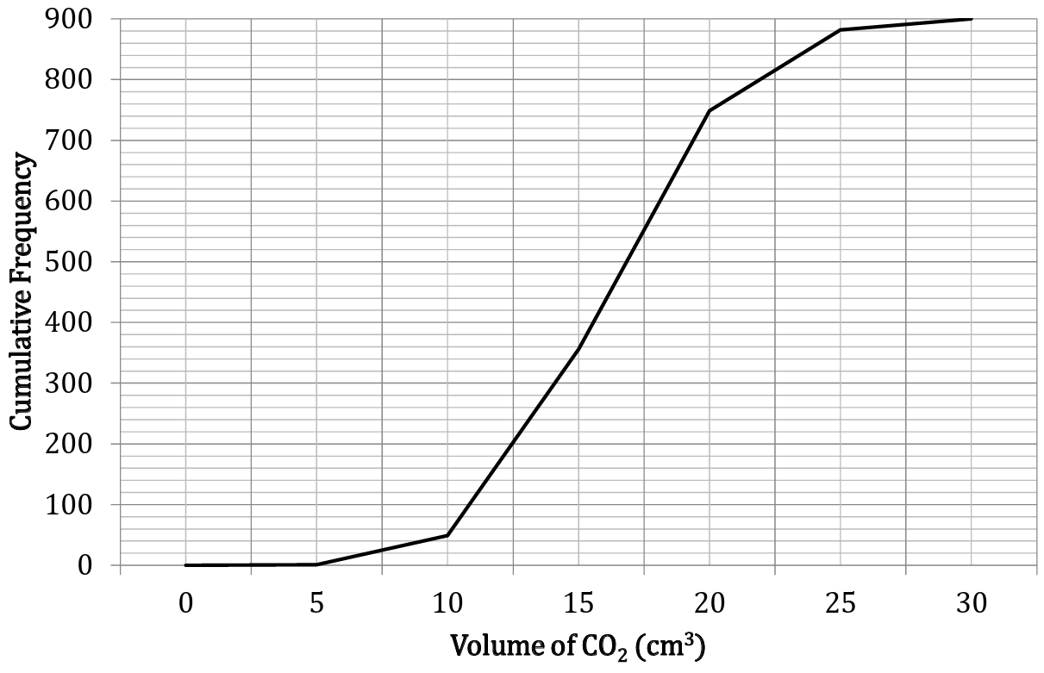
- Estimate the median and interquartile range of the data
- Identify the outliers, if there are any.
- Discuss whether these outliers should be removed.
- On the next six occasions, the machine reported negative values. Discuss how adding these into the data would alter the graph.

